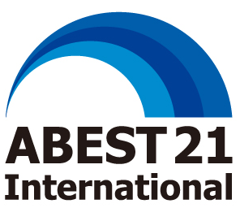

THE ALLIANCE ON BUSINESS EDUCATION AND SCHOLARSHIP FOR TOMORROW, a 21st century organization
5-4-29, Minami-aoyama, Minato-ku, Tokyo 107-0062, JAPAN
TEL: +81(3)3498-6220 FAX: +81(3)3498-6221 http://www.abest21.org/

2024

Full School Membership Application Form

Thank you for applying for the ABEST21 International School Membership. A Full School Membership is for educational institutions actively involved in management education on a global basis. Annual School Membership Fee is JY 120,000 yen. Please print all information.

I. Basic Information
1. Name of University:
Name of University:

Name of Rector:

2. Types of the University:
Please tick types of the University
□State University □Public University □Private University

3. Name of the Academic Unit (Faculty or School) applied to the Membership:
Name:

Postal Address:

Tel. and Fax:

www.

4. Dean of the Academic Unit:
Name:

Position:

Email:

5. The University and the Academic Unit’s Profile
Provide the University and the Academic Unit’s Profile using Sheet-1 within one page maximum.
6. Year of founding
Year of founding | University | Academic Unit

7. Total Number of Students and Faculty members
 | Students | Faculty members
University
Academic Unit

II. Educational Programs
- The Academic Unit’s Educational Programs
Provide the Academic Unit’s Educational Programs using Sheet-2 within one page maximum.

- Degree Programs offered by the Academic Unit
Name of Degree programs offered
Bachelors’ Degree programs
Masters’ Degree programs
Doctoral Degree programs

III. Recommendation Letter
Attach a recommendation letter from a delegate of ABEST21 International Full School members.

IV. Supplement Information
- The University and the Academic Unit’s Profile
- The Academic Unit’s Educational Programs
- Recommendation Letter

The undersigned certify the accuracy of the information provided.

The Dean’s Name and Signature Date

The President’s Name and Signature Date

For questions or assistance in completing this form, please contact ABEST21 International.

The Membership Application should be submitted to ABEST21 International Office. Please submit the application via email to abest21international@abest21. org.

Contact Information
ABEST21 International
5-4-29, Minami Aoyama, Minato-ku, Tokyo 107-0062, JAPAN
Phone: +81-3-3498-6220/ Fax: +81-3-3498-6221/ EMAIL: abest21international@abest21. org

Sheet-1: The University and Academic Unit’s Profile

Sheet-2: The Academic Unit’s Educational Programs

Sheet-3: Recommendation Letter

